Experiment 1: Try to access Internet from your notebook at different locations, such as home and campus, or building one and building 5 in YZU campus, and
- Show the IP addresses, hardware addresses, Mask, gateway, DHCP server, and DNS server addresses at each location for your notebook.
- Screen print what you see at your notebook and comment on the difference between them and explain what addresses remain the same.
- In order to complete this task, I went to global lounge(building 7),building 1, building 5 and connected to “YZU” wifi, then I opened windows terminal ‘cmd’ and wrote command ‘ipconfig /all’. 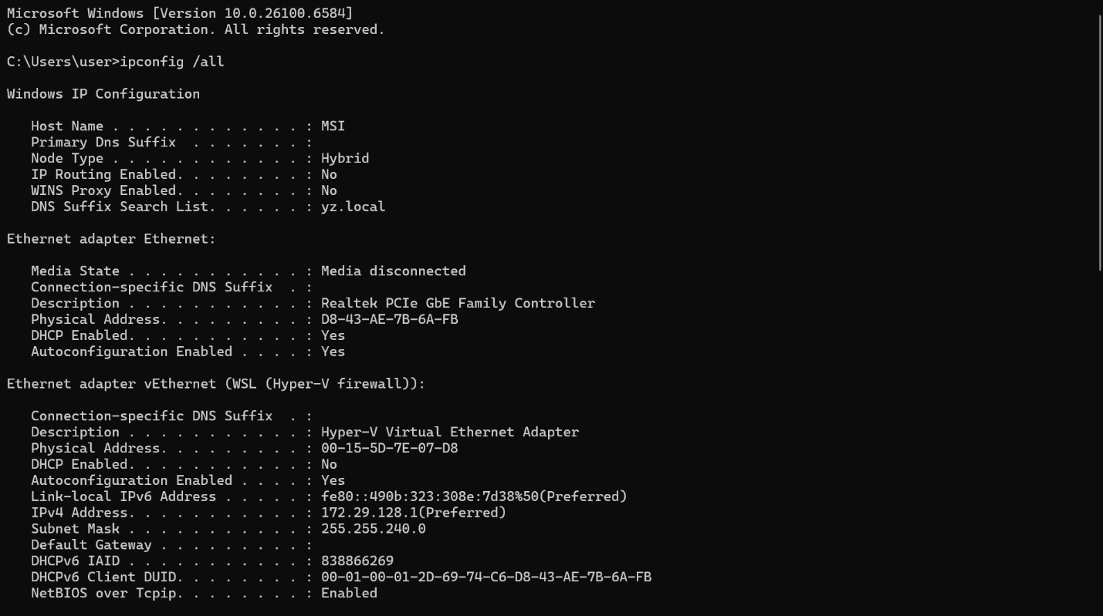
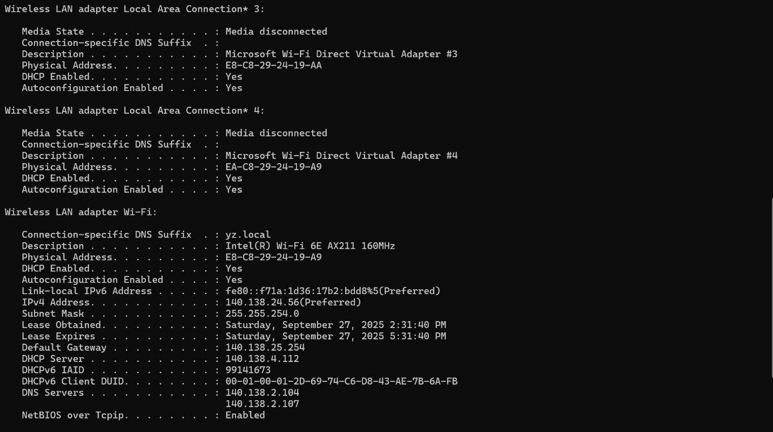
These screenshots show these parameters of internet connection:
• IPv4 address: 140.138.24.56
• Subnet mask: 255.255.254.0 (i.e., /23)
• Default gateway: 140.138.25.254
• DHCP server: 140.138.4.112
• DNS servers: 140.138.2.104, 140.138.2.107
• MAC (hardware) address (Wi-Fi): E8-C8-29-24-19-A9
• IPv6: link-local present (fe80::…%5), no global IPv6 shown
• DHCP enabled: Yes
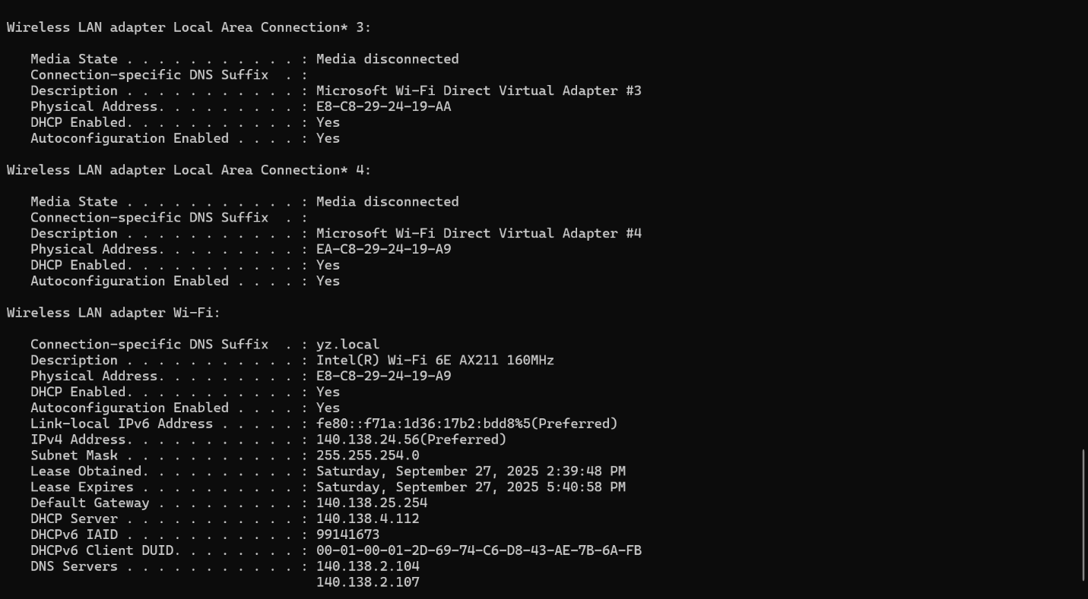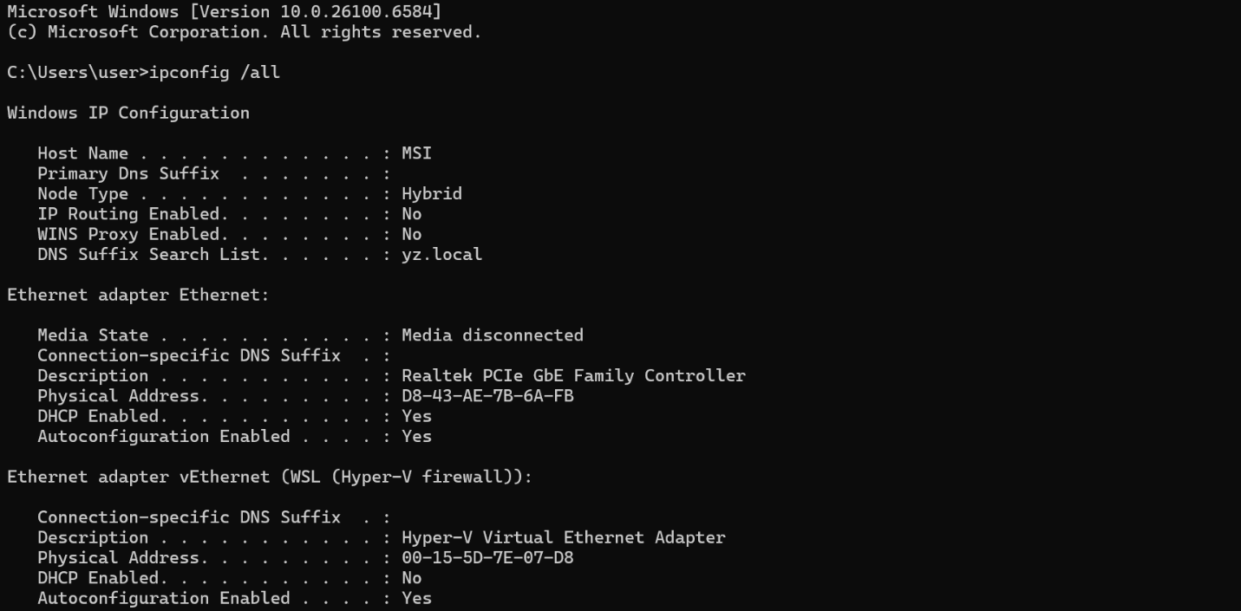

• IP address: 140.138.24.56
• MAC: E8-C8-29-24-19-A9 (Wi-Fi)
• Mask: 255.255.254.0 (/23)
• Gateway: 140.138.25.254
• DHCP server: 140.138.4.112
• DNS servers: 140.138.2.104, 140.138.2.107
• Notes: IPv6 link-local only; short DHCP lease (≈3h); Hyper-V/WSL vEthernet present but internal.

Task (b): Screen Prints & Commentary
Below are screen prints from ipconfig /all on the notebook for two networks, followed by a comparison of differences and what remained the same.
Location A — Campus Wi‑Fi (YZU)
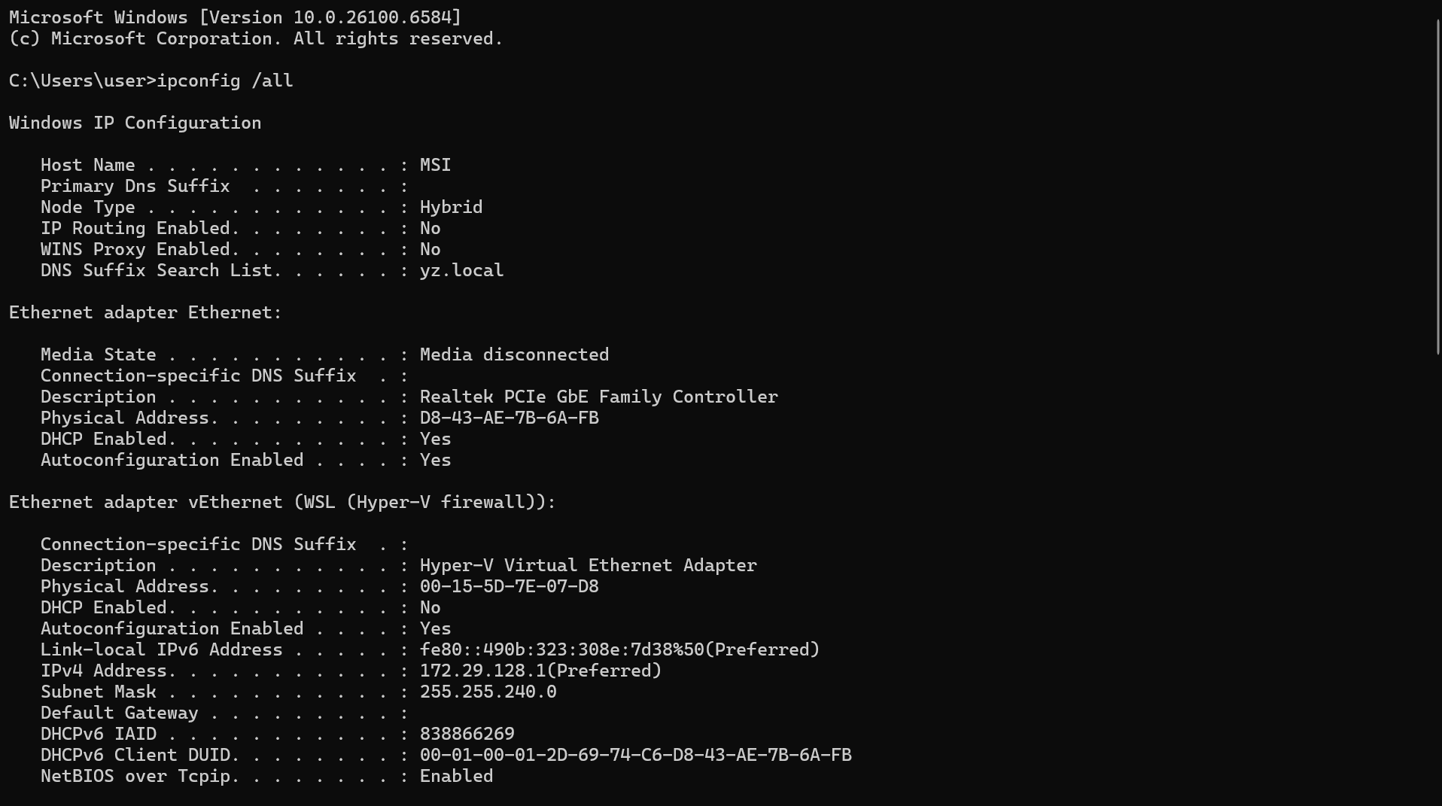
Campus Wi‑Fi: ipconfig /all (part 1)
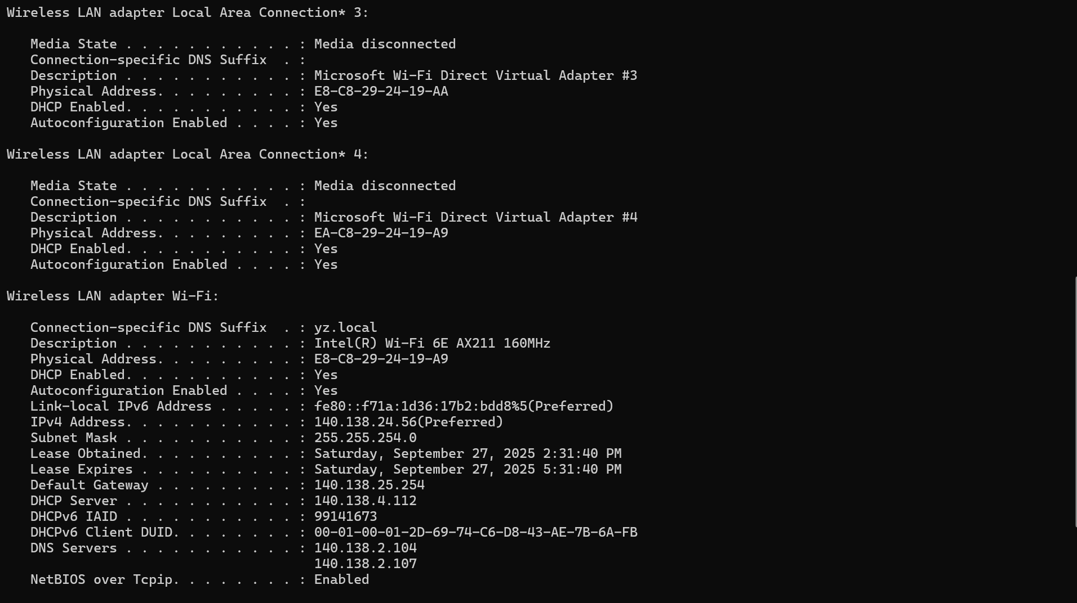
Campus Wi‑Fi: ipconfig /all (part 2)
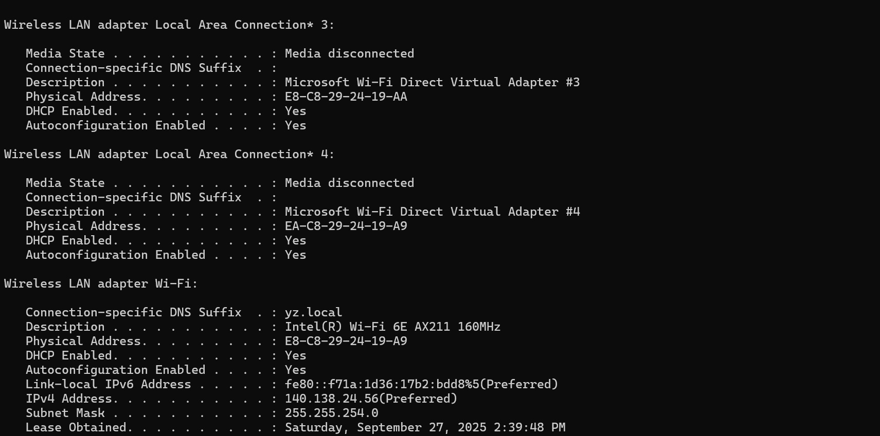
Campus Wi‑Fi: additional capture
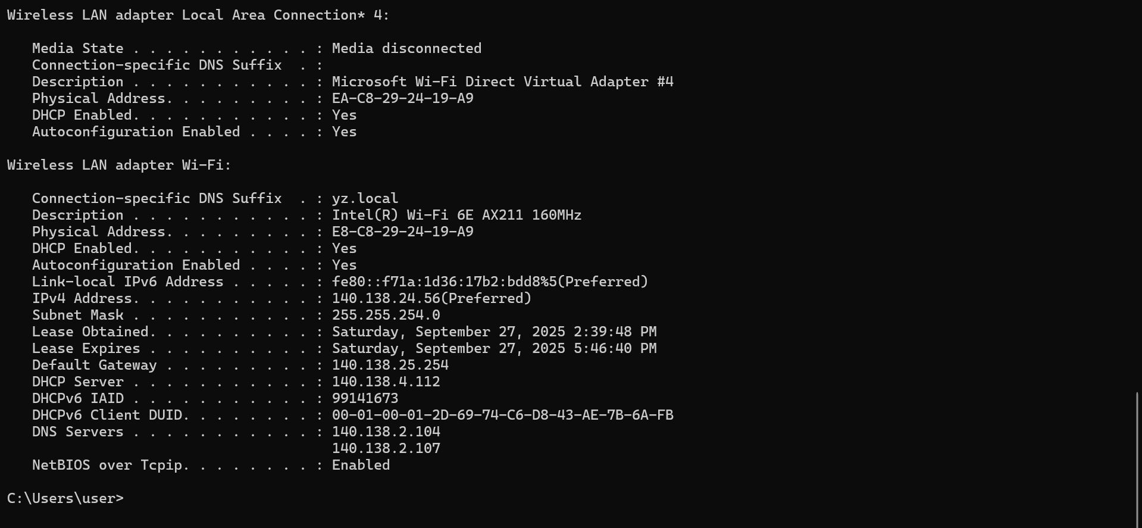
Campus Wi‑Fi: additional capture (details)
Key values from the screenshots:
Field | Value
IPv4 address | 140.138.24.56
Subnet mask | 255.255.254.0 (/23)
Default gateway | 140.138.25.254
DHCP server | 140.138.4.112
DNS servers | 140.138.2.104, 140.138.2.107
Wi‑Fi MAC | E8-C8-29-24-19-A9
IPv6 | link-local shown (no global IPv6 in capture)
Lease times | Obtained 2:39:48 PM; Expires 5:46:40 PM (Sep 27, 2025)
Location B — Phone Hotspot / Home
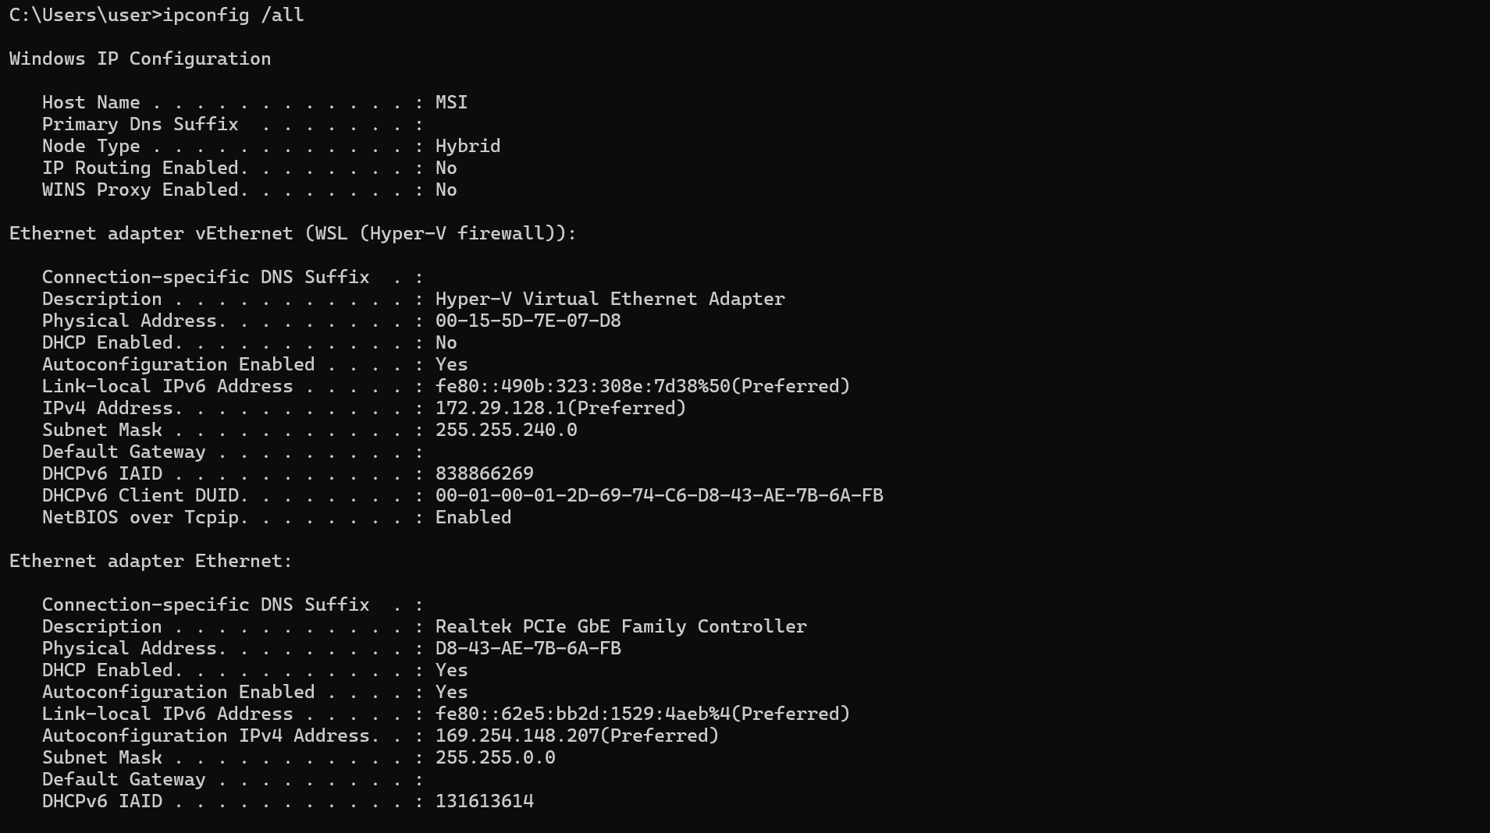
Phone Hotspot: ipconfig /all (part 1)
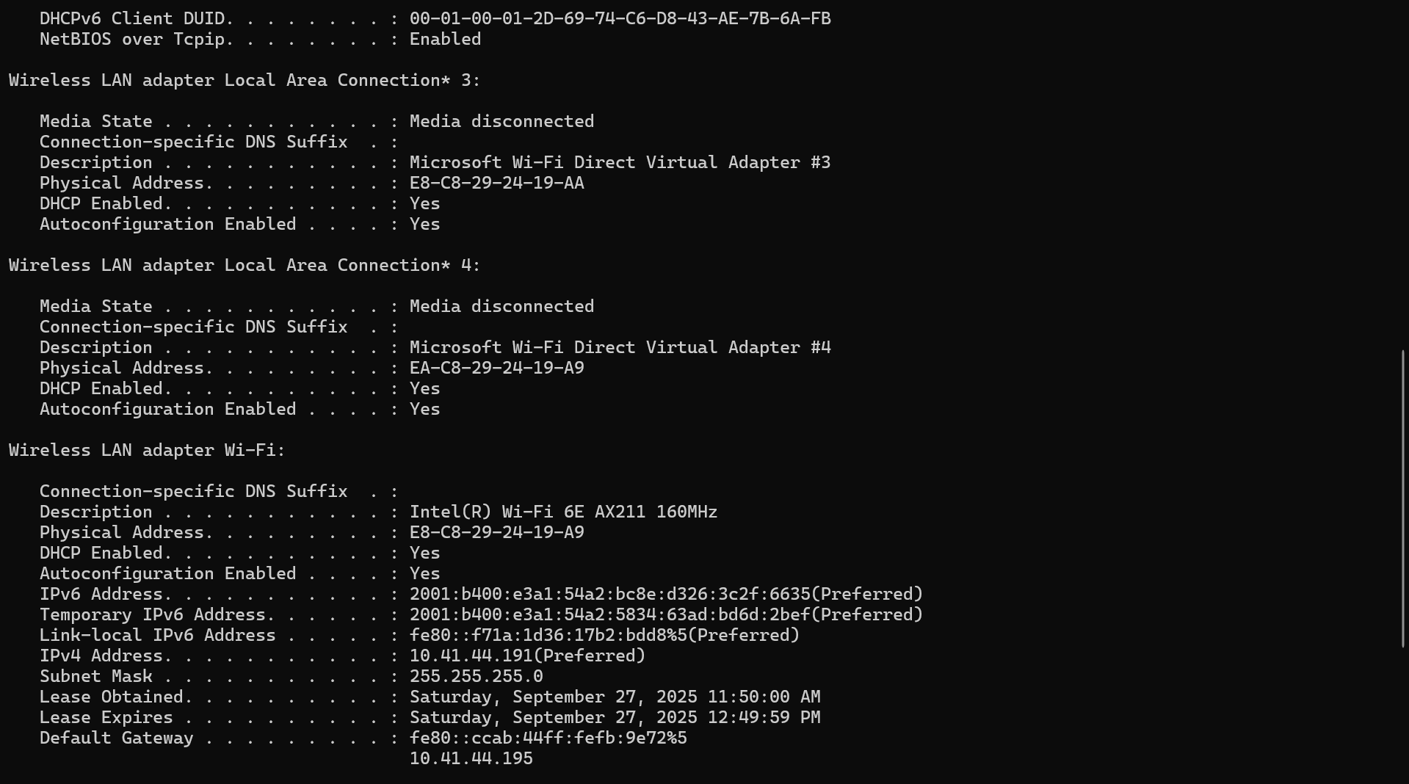
Phone Hotspot: ipconfig /all (part 2)
Key values from the screenshots:
Field | Value
IPv4 address | 10.41.44.191
Subnet mask | 255.255.255.0 (/24)
Default gateway | 10.41.44.195
DHCP server | Not visible in crop (likely the hotspot device)
DNS servers | Not visible in crop
Wi‑Fi MAC | E8-C8-29-24-19-A9
IPv6 | global IPv6 present (temporary + stable); link-local shown
Comparison & What Remained the Same
Differences:
• IPv4 addressing: Campus uses public 140.138.24.0/23; Hotspot uses private 10.41.44.0/24.
• Subnet mask: /23 (campus) vs /24 (hotspot).
• Default gateway: 140.138.25.254 (campus) vs 10.41.44.195 (hotspot).
• DHCP/DNS: Campus servers (140.138.x.x); hotspot values not visible but typically provided by the phone/carrier.
• IPv6: Campus capture shows only link‑local; hotspot provides global IPv6 (with privacy extensions).
Addresses that remained the same:
• Wi‑Fi adapter MAC address: E8-C8-29-24-19-A9 across both locations (suggests Private/Random MAC is off for these SSIDs).
• Adapter hardware/description: Intel(R) Wi‑Fi 6E AX211 160MHz.
• Same notebook hardware/hostname.

Experiment 2: Use PING and TRACERT commands to explore your network connectivity. Explain your setting and the results you find.
a.) Try to connect and disconnect an end host to the Internet and use PING and TRACERT to detect its connectivity. Explain the results you find.
What is a PING?
PING (Packet Internet Groper) is a network utility tool that sends out usually the ICMP (Internet Control Message Protocol) Echo request to the given server/web to find out the availability and the connectivity of networks, by measuring the communication latency time to send the packet and receive the response.
Here is a picture where I used the PING command while connected to the YZU wifi network. - Using the IP address:
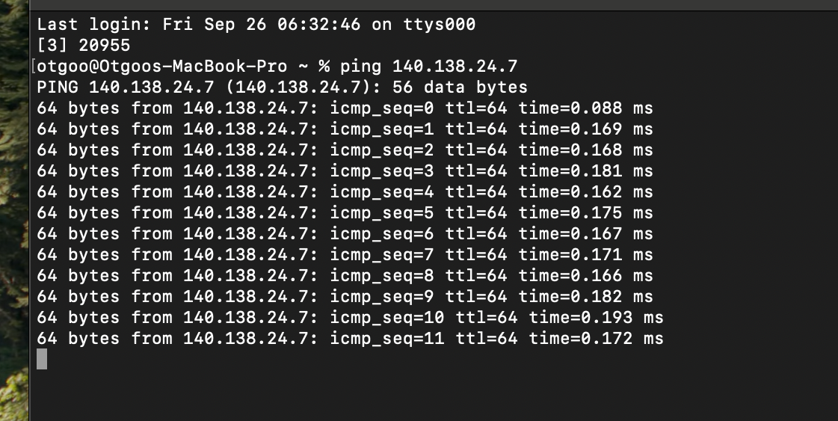
PING 140.138.24.7 - The Command
140.138.24.7 - The Public IP Address (IPv4 Using DHCP)
56 data bytes - The amount of bytes (data padding) per packet sent
64 bytes from - The size of ICMP Echo reply packet sent from the network/device.
ttl - Time to Live - The system sets a value set that decrements by one, every time the packet transits through a router.
time=0.088 ms - The Packet’s round-trip time

From this picture, we can see that the latency time is at a below average benchmark - (1 ms) marking the quality of the wireless wifi connection as excellent.

Next, I will be using the Mobile Hotspot Network for the ping command.
- Wifi network: At the Top.
- Mobile hotspot network: At the Bottom.

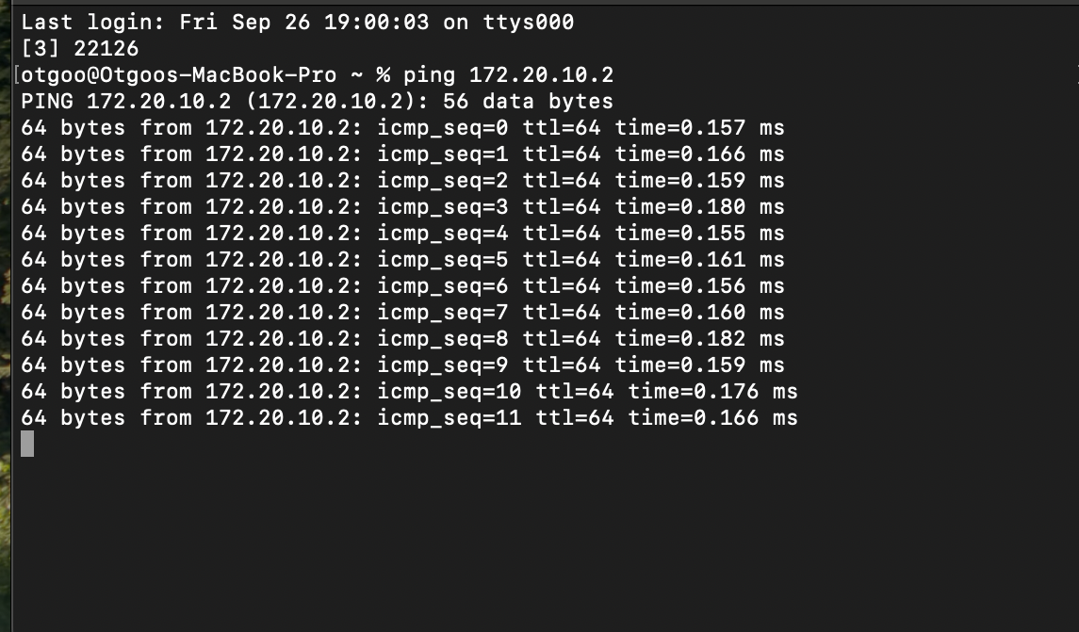
172.20.10.2 - Private IP Address (IPv4 Using DHCP)

The main difference is the speed of connections, and its stabilities. The Wireless Cellular Hotspot device was significantly slower in comparison to the wifi network, this fact also shows stability of those networks, and on its own the Mobile Hotspot is limited to location, amount of connected devices, etc.

Now I will disconnect both connections, to see what happens.

- Wifi Network: At the Bottom
- Mobile Hotspot: At the Top
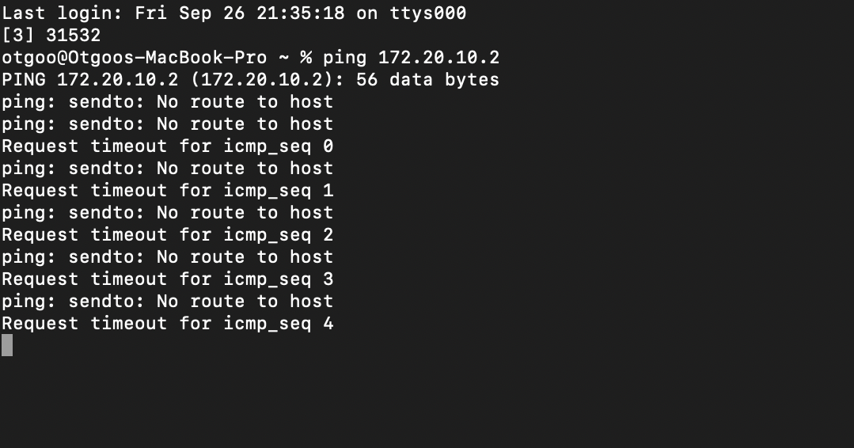
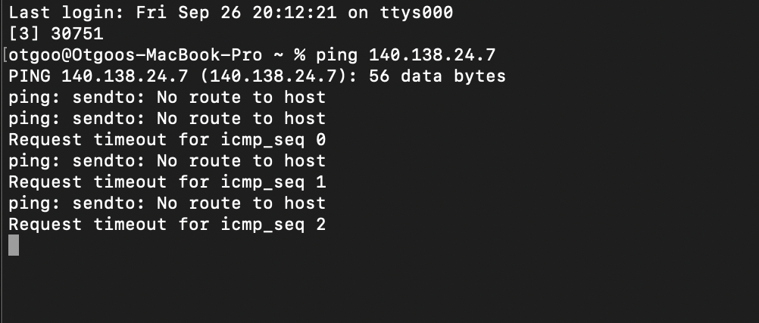

For the ping command both the mobile hotspot and wifi networks ping seemed to try 3 and more times of other routers/routes to find the right router/device to send the packet, when it failed it inputs the “No route to host.”

What is TRACERT?

TRACERT or command name traceroute is a network diagnostic utility tool which maps all the router/switches the packet goes through to get to the destination, going through each and every router called hops.

The picture below is when the TRACERT is used while connected.

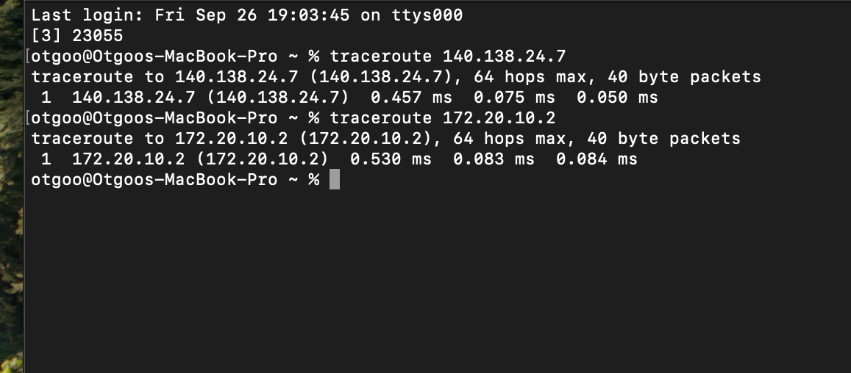
3 packets sent to the network/device so that the prompt shows 3 different latency times.
/useful for trouble shooting and finding the error./

The picture shows that both networks are one hop away from the connected end host, it also can mean it is directly connected, and the both speeds show excellent connections.

I will now try disconnecting and using TRACERT see what happens:
- Wifi network: At the Top.
- Mobile hotspot network: At the Bottom.

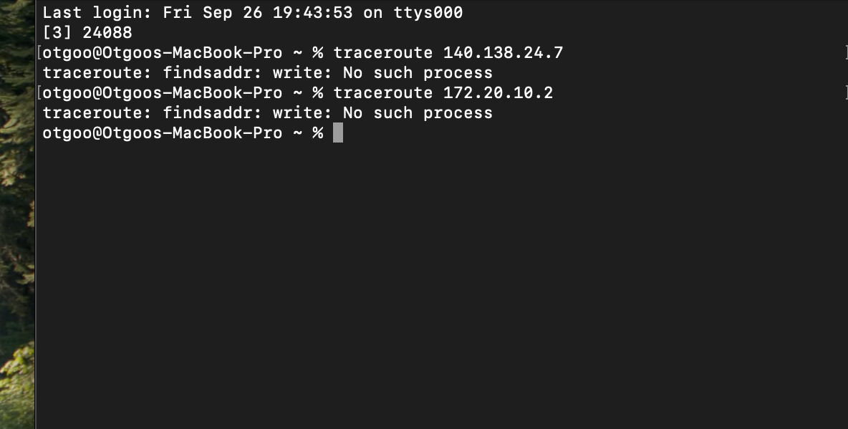
Since, the end host wasn’t connected to any networks, it is impossible to hop into different routers or maps, that is why the TRACERT wrote “No such process” found.

b.) Try to set up a network configuration so that the failure in connectivity to a host is due to a network device, such as a router, and use TRACERT to find the failure. Report what you found. You should illustrate your results by screen print of the results and then comment on them.

I will now set up a network configuration using the Mobile Hotspot where the host disconnected/has inconnectivity, to find the failure is going to be using TRACERT.
- When both the end host and host were disconnected. - At the Top.
- When the host re-connected, the end host stayed the same. - Middle.
- When the end host connected to another network while the Mobile hotspot was still roaming. - At the Bottom.

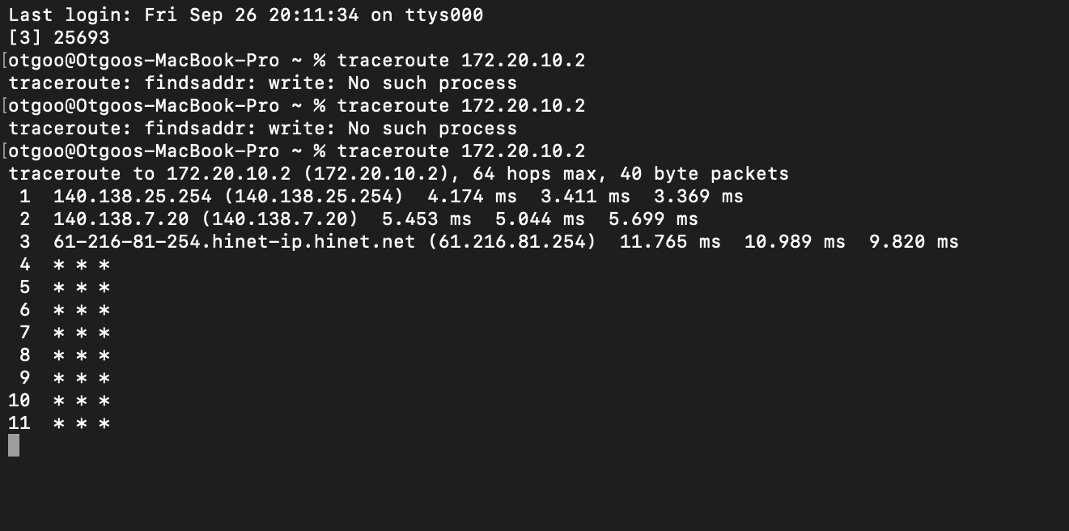
3. Shows that 3 hops were taken from the end host to the host/device:

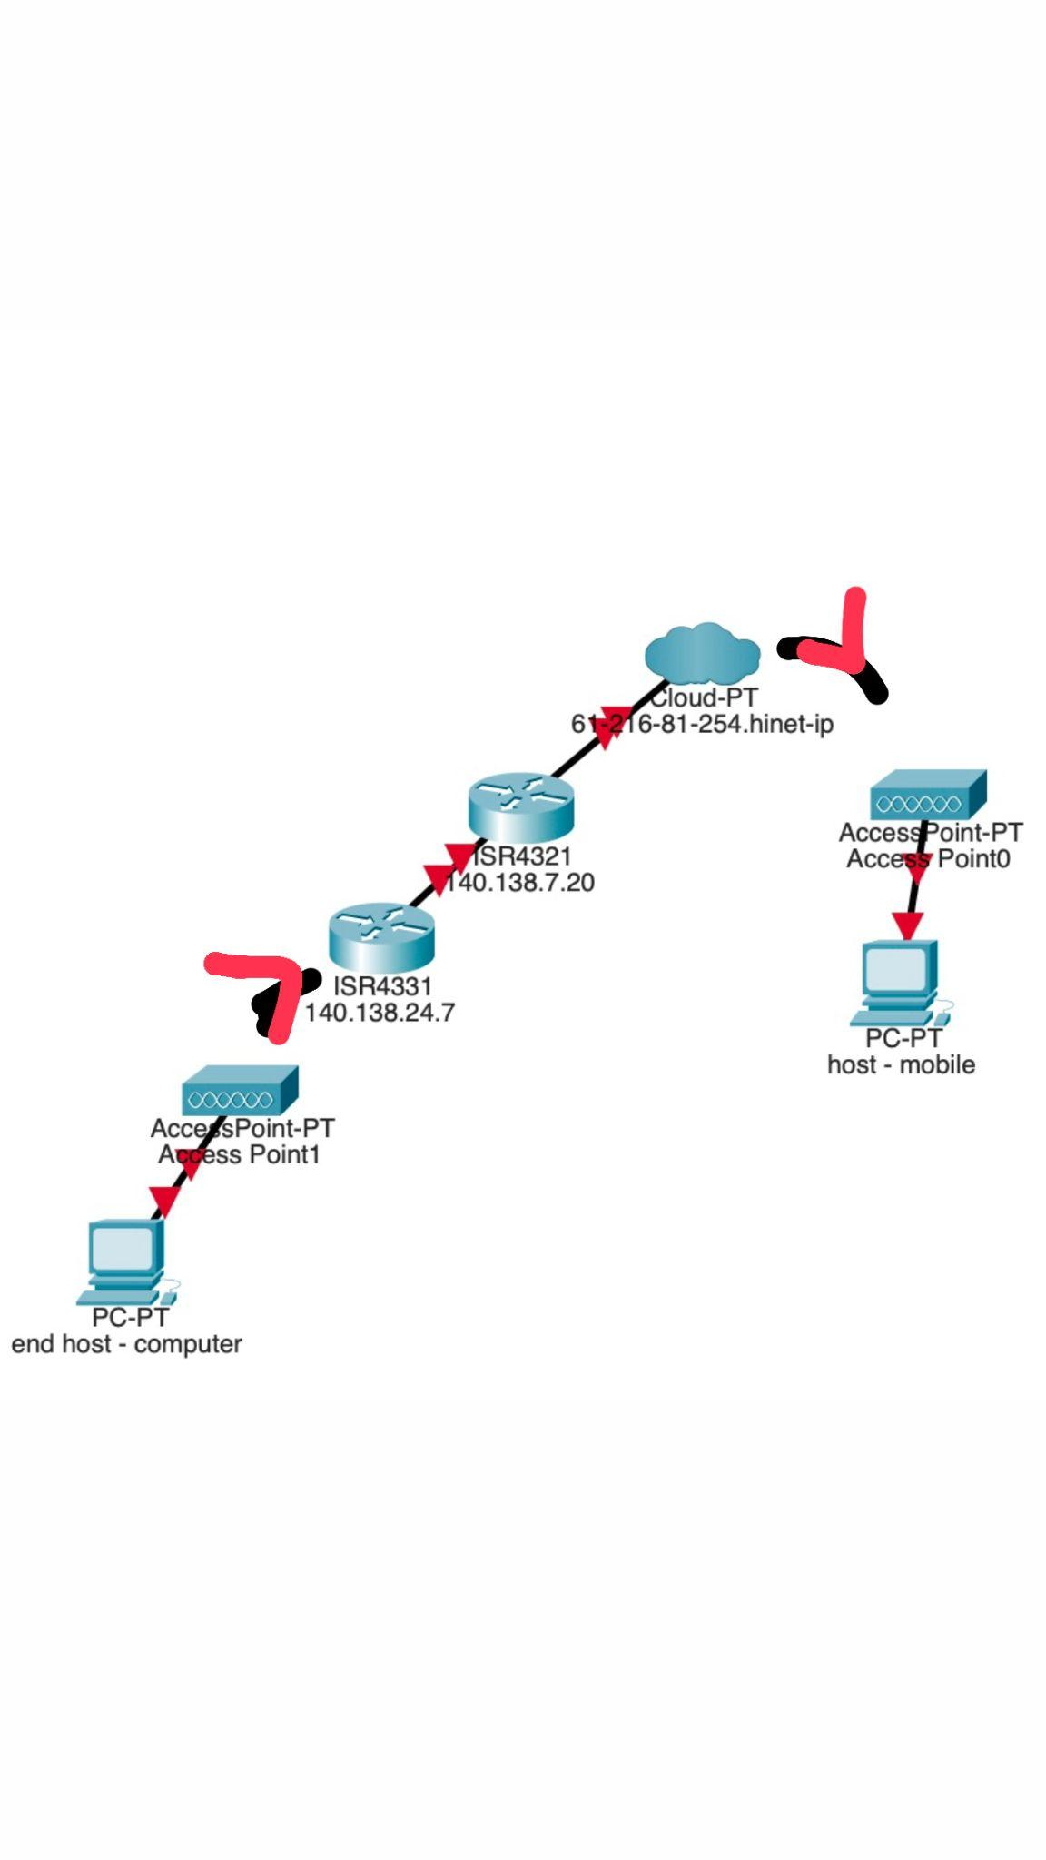
The first IP address is the connected network of YZU wifi, the second is an unknown one but could only guess it as a router bearing the IP address of 140.138.7.20, and the last is the WAN Hi-net telecommunication national ISP. The Access Points are the transmission mediums.

Using the mobile network as the hotspot and turning it off during test can be considered as switch failure, and denoted as (lines of 4 to 11) *** meaning at the hop 4, at a given time the packet got lost, timed out or was not received again by the end host.

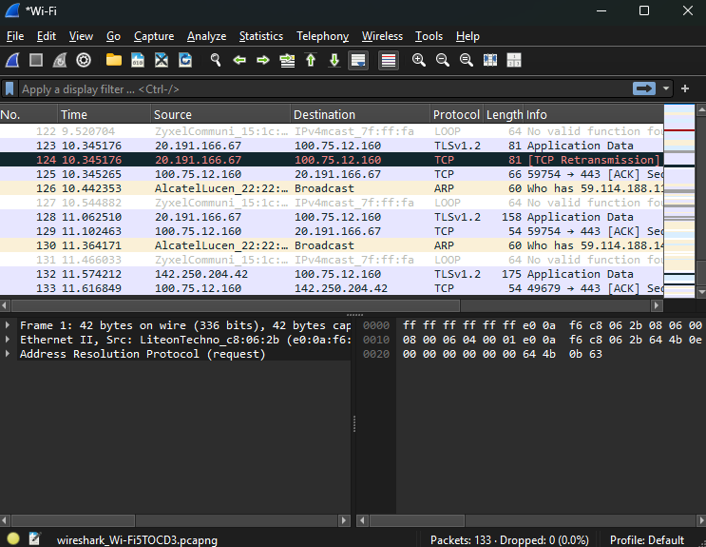

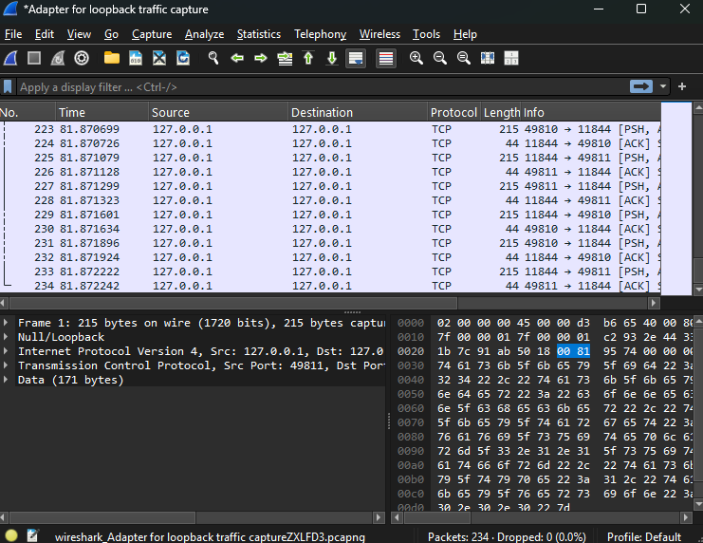

When I opened YouTube while capturing on my Wi-Fi interface, Wireshark showed a large number of TCP packets. This is because YouTube loads videos and webpages over HTTPS, which relies on TCP. At the beginning, I also saw DNS requests (UDP), which resolved the domain name (youtube.com) to an IP address. Once the IP was known, my computer established multiple TCP connections to Google’s servers. The continuous stream of TCP packets corresponds to the video data being transferred.

B.
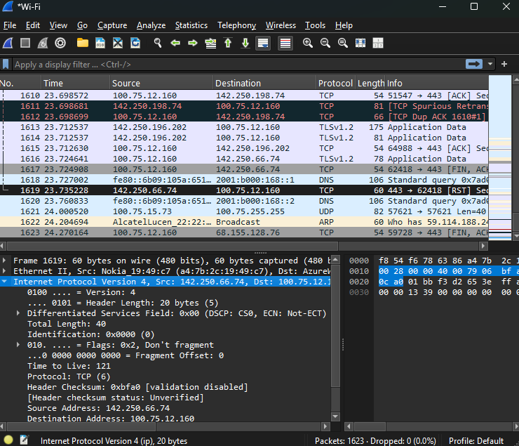
Packet #1619 is a TCP packet captured on my Wi-Fi interface.
- Ethernet layer: Src MAC = Nokia_19:49:c7, Dst MAC = my computer’s MAC.
- IP layer: Src IP = 142.250.66.74 (YouTube server), Dst IP = my IP 100.75.12.160.
- TCP layer: Src Port = 443 (HTTPS), Dst Port = 62418.
This packet is part of the HTTPS connection for streaming a YouTube video. TCP ensures reliable delivery, and port 443 indicates encrypted traffic. It appears because my browser is requesting video data from the server.
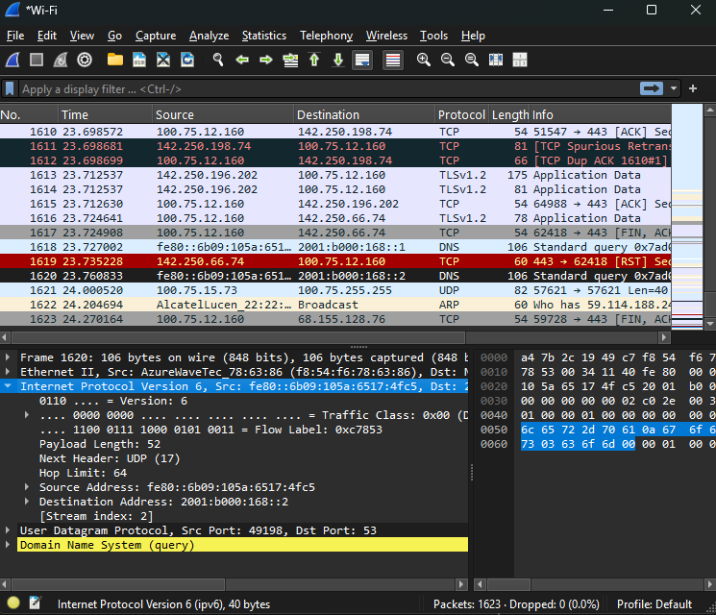
Packet #1620 is a DNS query over IPv6 captured on my Wi-Fi interface.
- Ethernet layer: Src MAC = my computer, Dst MAC = router/access point.
- IPv6 layer: Src = fe80::6b09:105a:6517:4fc5 (my PC), Dst = 2001:b000:168::2 (DNS server).
- UDP layer: Src Port = 49198, Dst Port = 53 (DNS).
- DNS query: my computer asks the server for the IP of a website (e.g., youtube.com).
DNS appears because my browser must translate the domain name to an IP before establishing a TCP connection for HTTPS. UDP is used because it is fast and connectionless.
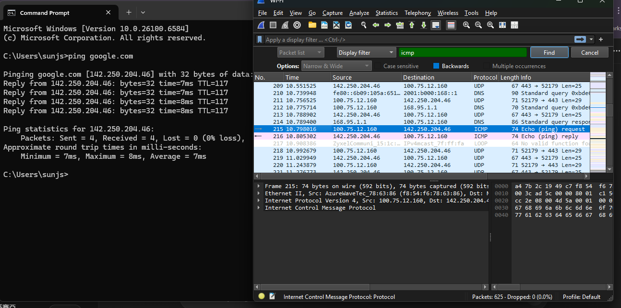
When I sent PING google.com, Wireshark captured ICMP packets.

The ICMP Echo Request packet leaves my computer and asks the server if it is reachable.

The ICMP Echo Reply packet comes back from the server confirming it is alive.

ICMP is invoked because ping is a network diagnostic tool to test connectivity.

C.
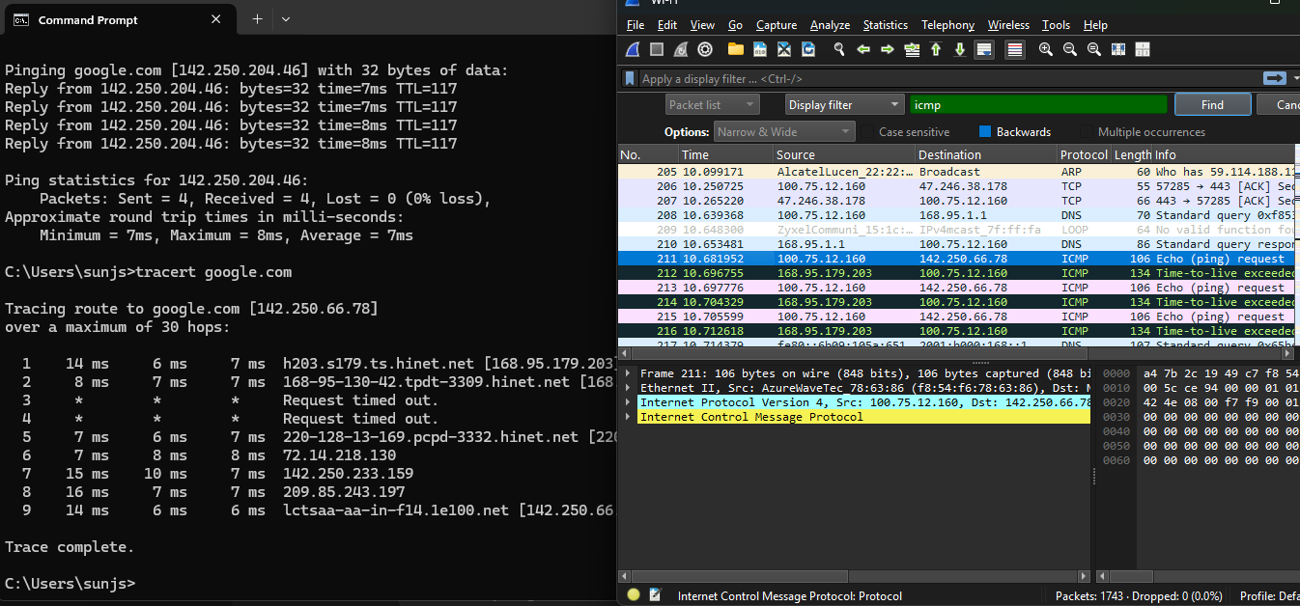
During TRACERT google.com, Wireshark captured ICMP packets with varying TTL.

Each intermediate router sent an ICMP Time Exceeded packet back to my computer.

The final destination sent an ICMP Echo Reply.

This shows the route my packets took through the network.

TRACERT is invoked to diagnose network paths and detect where packets may be delayed or blocked.

D.
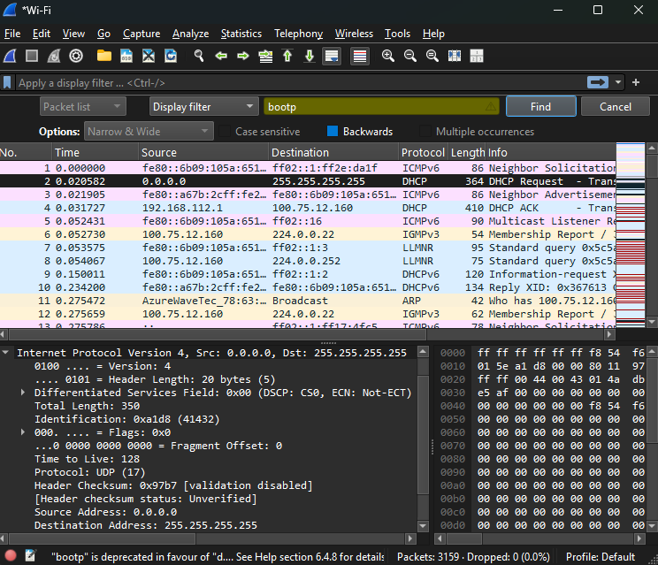
When reconnecting to Wi-Fi, my computer sent a DHCP Discover packet to find a DHCP server.
The DHCP server responded with an Offer containing an IP, gateway, and DNS.
My computer then sent a Request to confirm, and the server replied with ACK.
This shows how DHCP dynamically assigns network configuration.

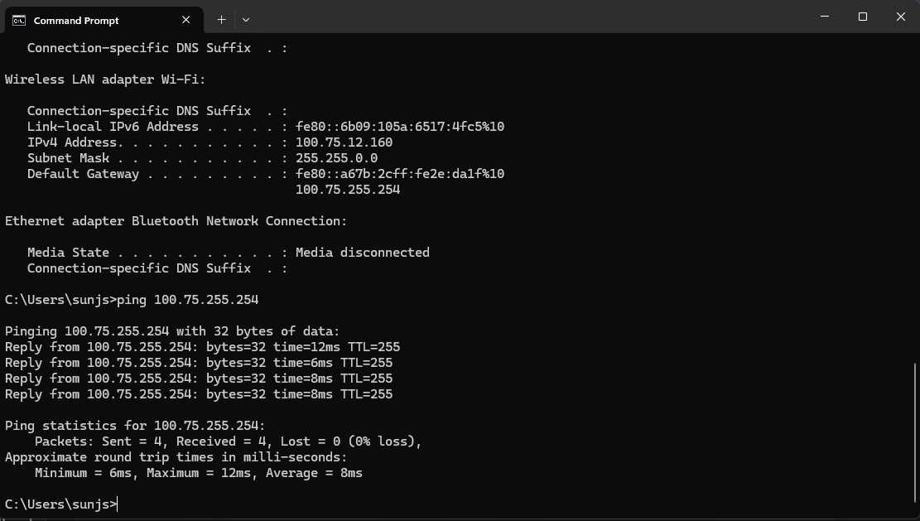
Before sending the ping, my computer sent an ARP Request to find the MAC address of the router.
The router replied with an ARP Reply, allowing my computer to send packets to it.
ARP is necessary for devices on the same local network to communicate using Ethernet.

